**“The Dangers of Emotions controlling your actions”**

A Bible Study on

**1 Kings 19:1-4**

1Ki 19:4 But he himself went a day's journey into the wilderness, and came and sat down under a juniper tree: and he requested for himself that he might die; and said, It is enough; now, O LORD, take away my life; for I am not better than my fathers.

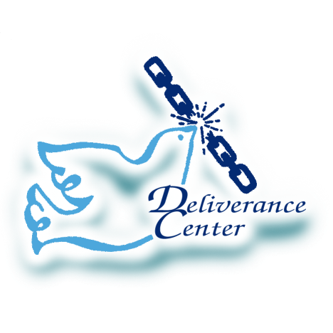

A Deliverance Center Publication

*1Ki 19:4 But he himself went a day's journey into the wilderness, and came and sat down under a juniper tree: and he requested for himself that he might die; and said, It is enough; now, O LORD, take away my life; for I am not better than my fathers.*

1. The Emotions control actions
2. The Emotions must be guarded

NOTES:

**We appreciate your interest**

**in the Word of God.**

**More publications are available upon request.**

CONTACT US:

Deliverance Center

1008 Congress St.

Portland, Maine 04102

Visit us on the Web at:

[www.thedleiverancecenter.com](http://www.thedleiverancecenter.com)

Email:

[info@thedeliverancecenter.com](mailto:info@thedeliverancecenter.com)